Strayer University

**Website Migration Project**

Week 10

**Term Paper Assignment**

for the

Course of

Systems Analysis and Development

06/12/17

By

Kennedy Kabaso.

Professor: Irene Hoskins.

**Website Migration Project**

This paper is about the Tony’s Chips which has recently been sold to a new independent company. The new company has hired me to manage a project that will move the old Website from an externally hosted solution to an internal one. Before I go any further, I would like to define Website migration. According to an article and I quote “Website migration is the transfer of a website from one web host to another. The move requires the migration of all integral website files to the new host.” Then will get into consideration of the destination site which is a website with an assortment of content and jumping off points, intended to serve as a portal to the web for its users. Moreover, I will talk about the process which are needed, the tasks which will be carried out, the hardware and software involved in this process.

**Tasks**

In this assignment, I’m going to explain five task which are needed to do this whole process. Then broken those task into subtask to make it easy to understand. Therefore, the details are as follows:

1. Hosting the Website internally.

* Alternatives for self-hosting the site
* Database types like MySQL and SQL server.
* Webservers such as Apache.

2. Testing the internal site.

* Carryout the network test.
* Making sure Database is working good
* Making sure the drivers are working on hardware components.

3. Building the System architecture.

* Setup a WAN.
* Setup all Servers Needed.
* Setup Databases.
* Install software on the system.

4. Moving the website to the New Place

* By transferring files.
* Move inventory to the Database.
* Update software’s on the new environment.

5. Transition period.

* Train the people how it works.
* Put in place Maintenance issues
* Handle over the project to the System Analysis.

Lastly, I will meet with the Authority to handover this project and discuss some challenges ahead of time and give them easy solution should any issue raised. I have summarized the tasks by building a Gantt chart which is showing all tasks associated with implementing the Website and the report below which will be taken to management for approval. The Gantt chart shows how long the tasks are going to take. The duration of each task is in hours as you can see from the chart.

**Gantt chart**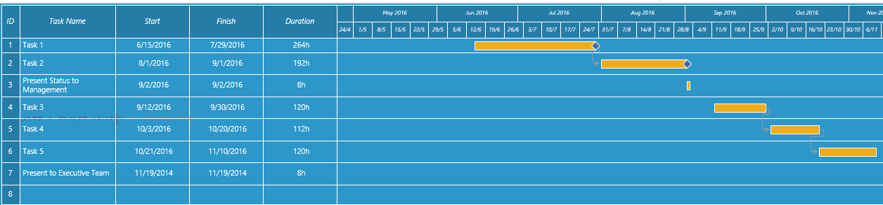

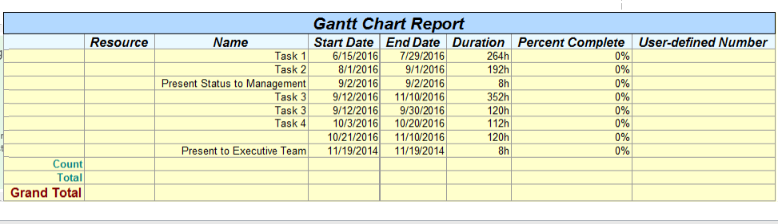

**First Step**

The first thing to do is dealing with the company which is hosting the site now and setup the environment on the new server which is internal. Then setup the database on the internal envelopment were the new site is going to be moved. Then deal with mails services, Network architecture, the security measures, the storage and bandwidth. In addition, the server software which will work with the computer on the internal computers. The most important thing is the databases which needed to be taken into consideration because it will handle a lot of things. As soon as these is done, then the process need to start.

**Alternatives for self-hosting the site**

**Second Step**

Hosting this site is going to be done internally which is going to save the company money. We are going to have web servers, databases which will result in bigger space needed. For this to take place, they will be maximum security and a firewall because storing all these internally might put the data at risk, therefore, a very trained Information Technology personal will be needed to maintain this. In addition, less monitoring and bandwidth will be necessary because it is on the internal.

On the other hand, if the company start having a lot of traffic and everything start becoming un manageable, that’s is when it can start looking for an external Databases and servers which can be taken care of by another company. But, the webservers can be kept internally

**Operating system**

To make sure the whole web architecture is well secured and running without worrying about the antivirus, I would setup this on a Linus operating system. It is an open source operating system which can be downloaded and changed that can result in an increased in different version of it. It is a freeware which can save the company money for software. Moreover, it has a wide range of options which are available to users and it also has an increase in security. The biggest advantage this has over window operating systems is the security flaws which can be caught before they become a problem for users. In addition to Linux operating system, I will install Apache, MySQL, and PHP which will create a good working environment.

Linux on the other hand has some disadvantages, over window like drivers which is a big problem. During the installation, you must make sure the hardware component of the computer has drivers available. The absence of them might result in mount functional of the whole operation. But that should not be an issue since the company has some Information personal who would oversee that assignment. Therefore, Linux will be the best choice of the operating system for this Web architecture.

**Testing the internal site.**

**Third Step**

Once setting up the news environment is done, am going to the next step which is carrying out different test to make sure everything is working on the internal side properly. I will start with the databases which is suitable for this place which is the same as the external called SQL server and MySQL. These will be enough to handle the traffic of customers because the same number will be buying chips. Therefore, I will need to maintain the same capacity. Then test the security software and the firewall to keep the site safer by making sure no unauthorized person can get access. Lastly test if everything is working on the network work level.

**System architecture.**

**Fourth Step**

As this company will be handling selling chips and the company’s leadership was very concerned about redundancy for their site, insisting that a back-up site be available as a failover in case the main site goes down. In addition, they want the site redesigned to allow customers to order products online. Therefore, two webservers and two databases will work as RAID (redundant array of independent disks) which is a way of storing the same data in different places on multiple hard disks to protect data in the case of a drive failure. All these will be put on a wide area network which will be behind a firewall. Moreover, to make an existing Website with minimal downtime, and provide a disaster recovery solution to ensure the site is always available, two webservers and two databases are going to be installed at different location of the company so that if there is a problem on the other location, the other webserver and the database will take over doing the job which will make the customer continue buying the chips on the website without knowing the server or the website is down.

To make it easy to understand, I have put this architecture in form of a flow Chart below.

**The Architecture Flow Chart**

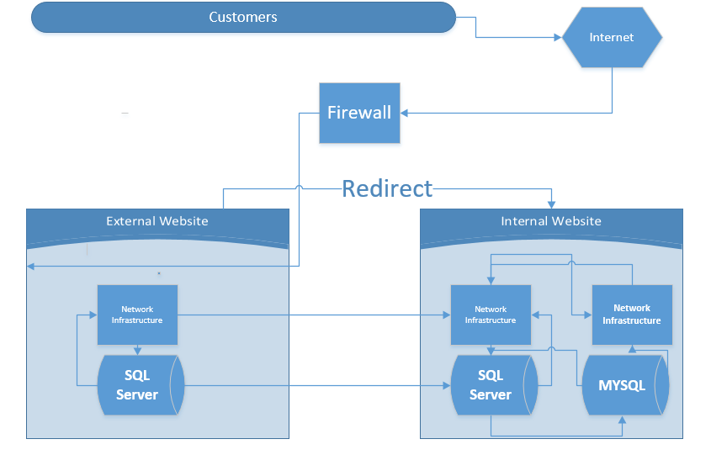

As you can see how I put the whole process in a form of the flow Chart above. In the flow chart, A person can browse the old website on the external website using the internet which must go through a firewall, he is going to be redirected to the new website which is internally where he can do his transaction which is going to be handled by the web server and the database. If one location is down in case of power failure or disaster, then. the other location is going to pick up and running smoothly. So, the customer is not going to notice the different because everything will be running and his tranction will be moving. This will result in business keep on going at any time and making customer happy all the time.

**Sixth Step**

After setting up the news environment and carry out test, I am going to the next step which is moving pages of the website one by one to the new place which is the internal. This can be done by transferring files using transfer file programs. This process can be frustrated no matter how fast someone can be because mistake can be made. The transfer of DNA servers from the old hosts to the new one takes between ten hours to eighty hours when requested has been made to the new registrar. Moreover, transferring websites, dealing with the databases, software installation and other small activities can take a day for the web to start working normally. However, there is an easy solution which can be used. This formula is to use an advanced FTP login routine which can work on a new site which is configuring before DNS is changed and transferred to the new host. The result in the user without knowing what happened behind the scene. All they see is the website running normally.

The most important thing to do is not to tell the old host your plan before moving everything because they might remove every file there. The following are the things which are needed to do before call the old host and report your move. They might bring your business down by destroying everything which you have and have worked for and they cannot be taken to court because they will deny that case which might end up as dismissal.

* Finish moving all files before cancel the contract
* Downloading every Backup Files
* Making the Transfer
* You should make sure the Databases are working nicely
* Change to the new name server.

Now everything is in place and it is working ok, am going to show how this works by an event of a customer ordering a bag of chips from the new Website which has been put in place in form of a use case diagram below.

**A use case diagram for the Customer ordering a bag of chips.**

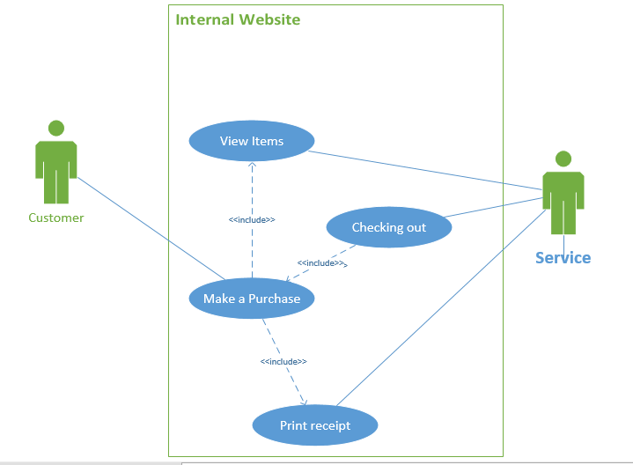

**Internally hosted Website requirements**.

The first thing which is needed after implementing the internal hosted website is the maintenance of the system which needs to be taken serious. The IT personal should start putting in place all varies maintenance of the system and these are as follows

* Preventive maintenance
* Corrective maintenance
* Adaptive maintenance
* Perfective maintenance

The next thing which should be consider as well is the security of the website. For the company to be doing business smoothly, there is a need of all king of security such as follows

* File security
* User security
* Physical security
* Application security
* Network security

There should be a way of backing up the data, therefore backup regularly and recovery rules should be plan and put in place which should be done most of the time. Software should be installed on the servers, on the network and updates should be schedule either weekly or monthly. In an event of an earthquake, a quick recovery policy should be put in place as well which can be at another location of the server within the company. Finally, the website should be monitored all the time to make sure everything is running smoothly and the unauthorized activities does not take place

**Seventh Step**

After doing all the above-mentioned staff, there are other things which must be done to this internal hosted website before presented to the high authorities, which is the performance of the site and its success. This can be find out by knowing how many users visited the web without any problem. If there are few users compared to the past, then there is a problem which need to be addressed. This can be measured by tracking how many hit the home page is getting of the site. In addition, you can also compare the number of transaction which are conducted on this every day and compared with the past data as well to determine the usual thing which used to happened before the migration. In addition, the speed of the operation needs to be monitored by download and upload files to the server. After accessing the above-mentioned things, then a better decision can be made how the new hosted internal website is doing. Then it is time for the higher authorities to take over and the IT team.

**Conclusion**

Finally, after planning, choosing the type of operating system, do the installation, moving the website to an internal environment from the external one and finishing carrying out test, Tony’s Chips would be working smoothly. Customer can buy chip by visiting the website and do all king of transaction without worried about anything. The migration, should have the number 301 which is redirected to a specific URL on the new one rather than 404. In addition, the old ranking would be retained and you will not have to start from scratch on the new domain.

**Bibliography**

1. <http://www.wisegeek.com/what-is-website-migration.htm>
2. <https://moz.com/blog/web-site-migration-guide-tips-for-seos>
3. <http://media.amazonwebservices.com/CloudMigration-scenario-wep-app.pdf>
4. <http://searchstorage.techtarget.com/definition/RAID>
5. <http://www.wpexplorer.com/migrating-wordpress-website/>